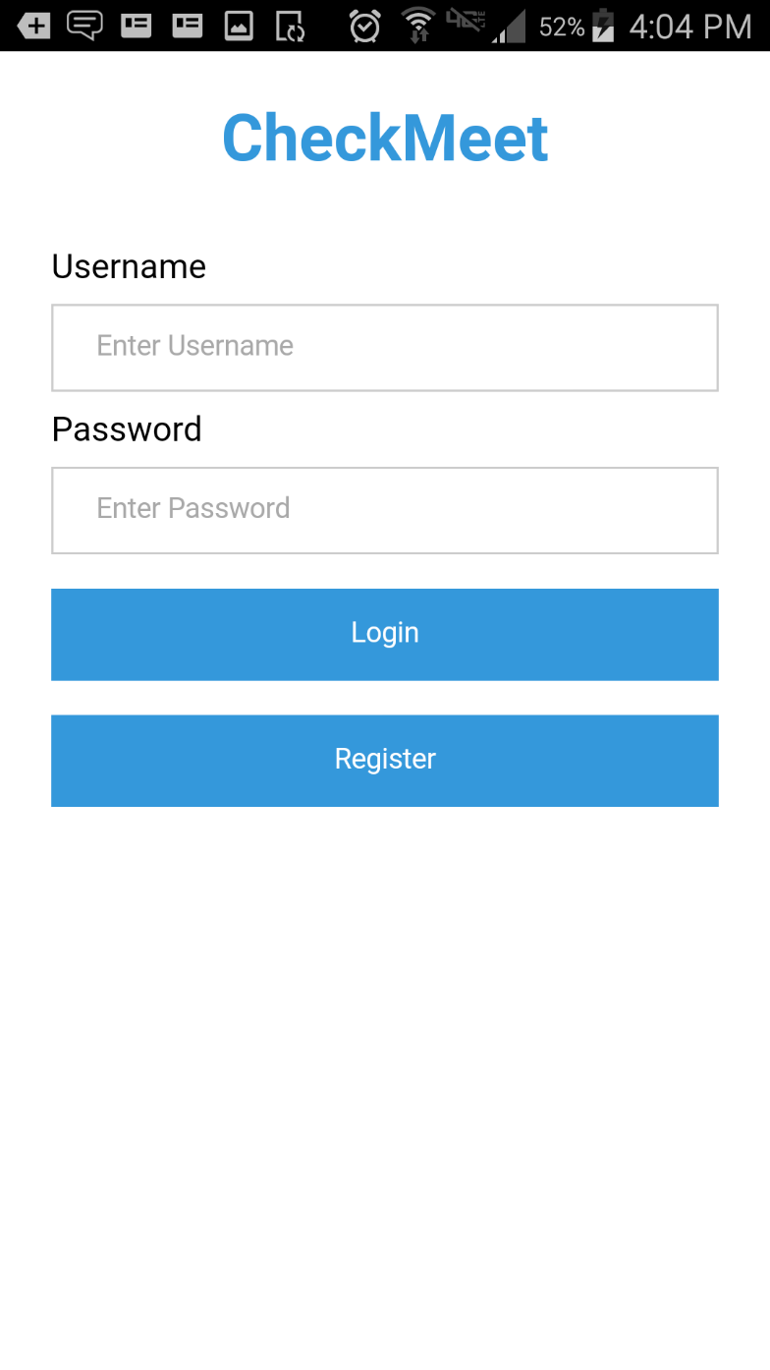

Checkmeet is a social media app centered around the concept of checking into places, much like in Facebook.

The idea is to allow the users to come back to the places that they’ve checked into, and communicate with those that may have been at the same place at the same time.

This is the log in screen for the app. The credentials are handled through AWS Cognito.

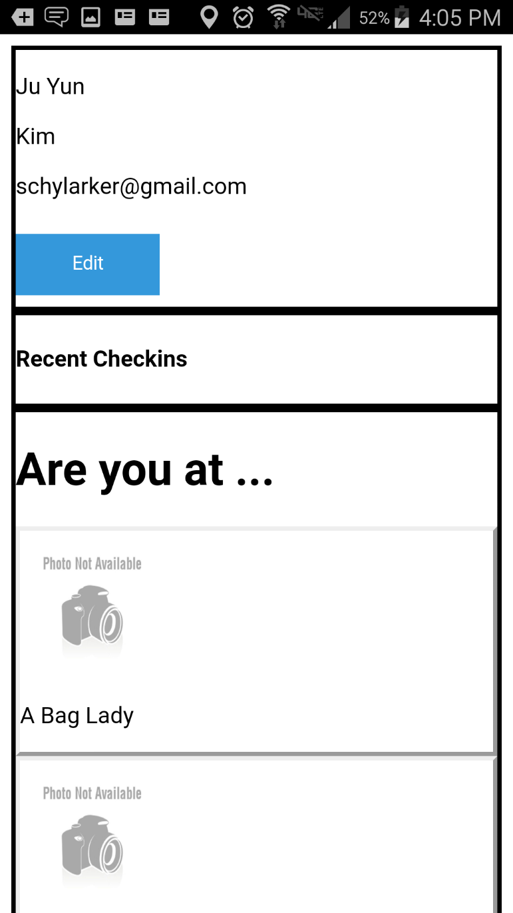

This is a working, but rough model that display some of your profile information, as well as recent checkins and a list of nearby places.

The nearby places are attained through API calls to Google Places, using the device’s GPS location.

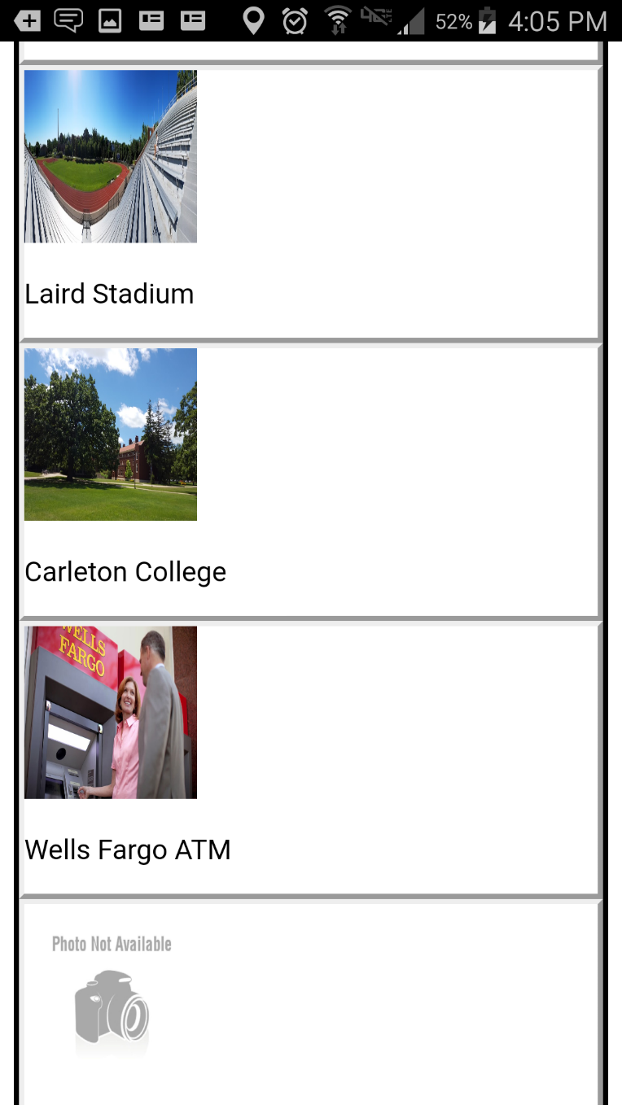The list of nearby places displays the name and the first image available on the specific Google Place object. In the works was adding additional information such as distance from the user, and possibly filtering places that wouldn’t really make sense to check into (such as Wells Fargo ATM).

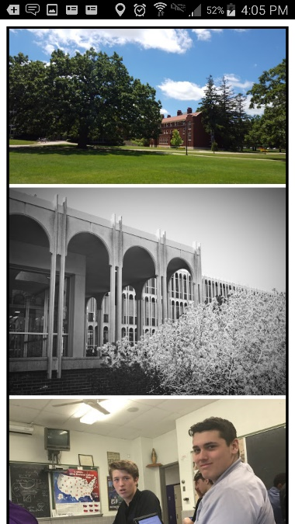When the user taps on one of these places, a more detailed page on the place pops up. The user is automatically checked in, and their username is displayed in the checkins box. It contains up to 10 more images, and some basic information about the location.

It also shows the users that have already checked in, and any posts that others might have left.

The checkins and posts are handled through API calls to those made in AWS API Gateway, which exposes read, write, and update functions in two different tables in AWS DynamoDB.

In further development, the pictures would have been formatted, and instant update to the page if there had been another post, possibly using some socket protocol.

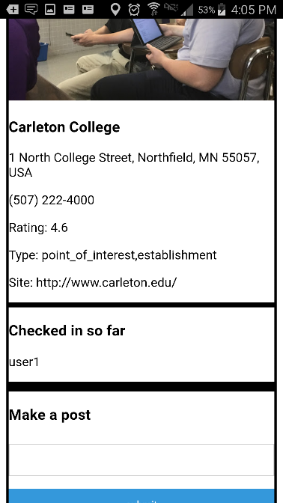

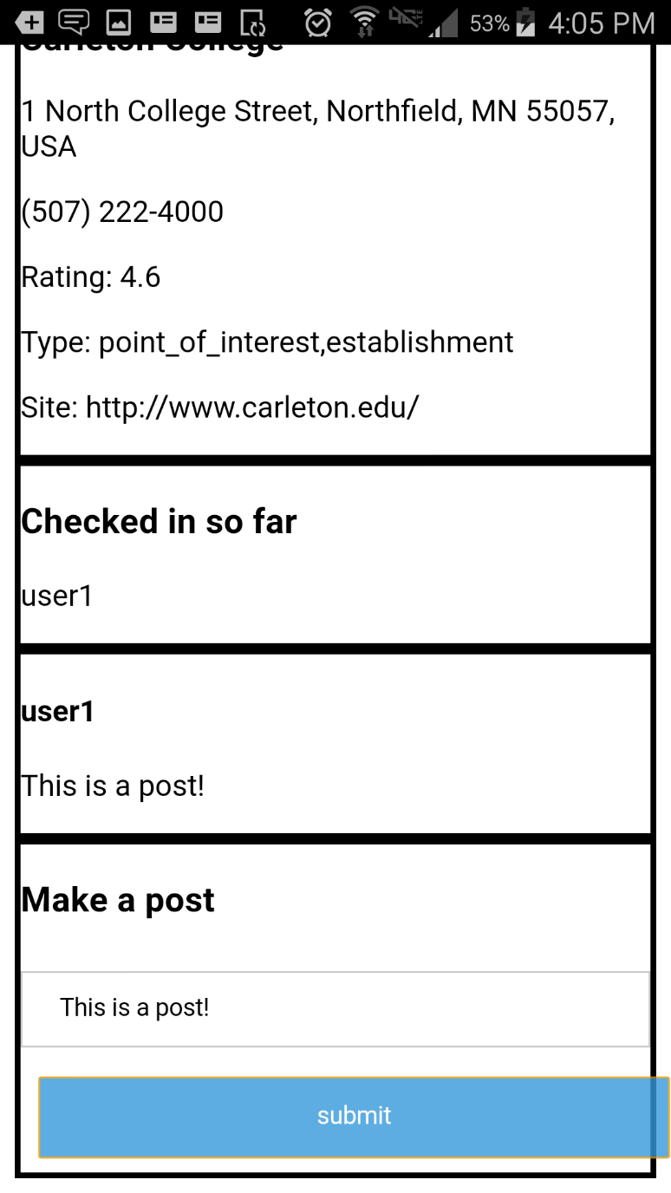

This is a demonstration of a user making a post.

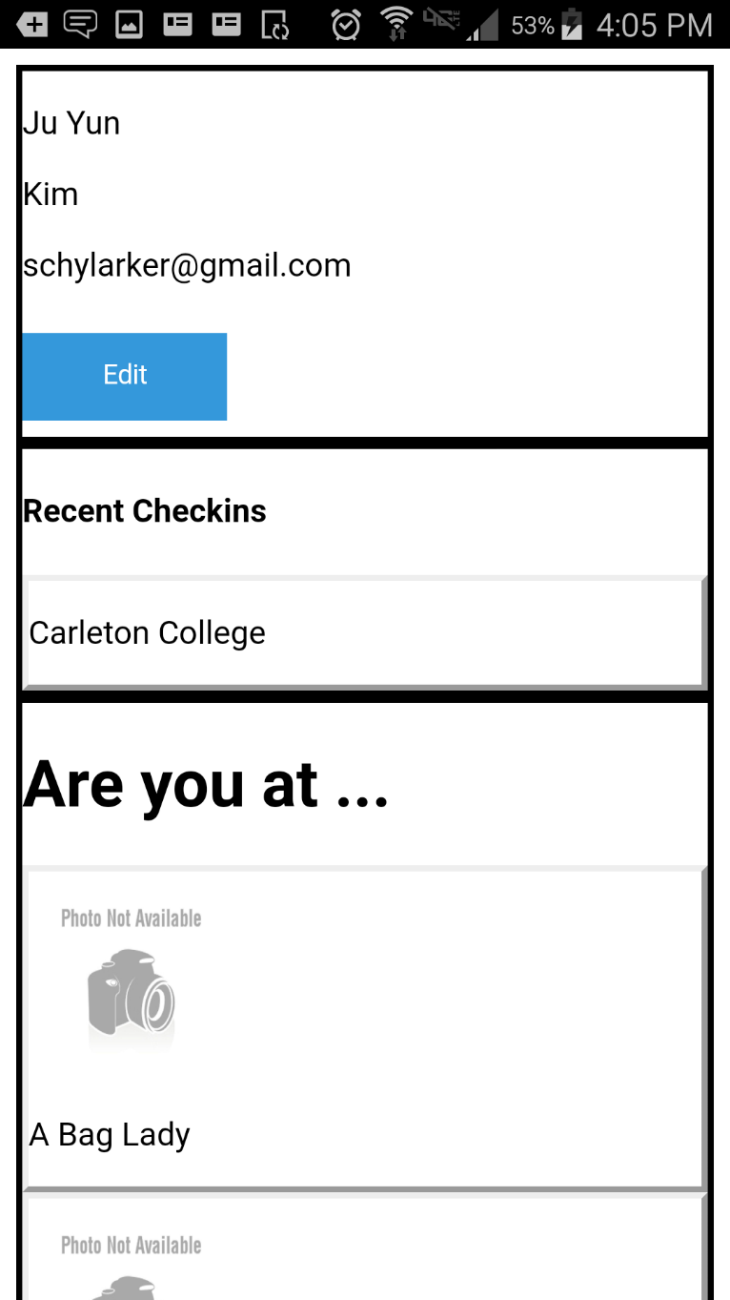When the user returns to their main page after checkin into a place, that place will appear on their list of recent checkins.

The user can then tap on one of those places to return to that page, and communicate with others who’ve also checked in.

Being a prototype that was to demonstrate the idea to investors, there was not a lot of aesthetic polishing done, but much of the core functionality was implemented over the course of about 60 working hours.